**Temporal effectiveness of biodiversity surrogates in**

**coral reefs in the British Virgin Islands**

Nicole B. Keefner

Biological and Environmental Sciences

Temporal effectiveness of biodiversity surrogates in coral reefs in the British Virgin Islands

Nicole B. Keefner1

1Department of Natural Resources Science, University of Rhode Island, Kingston, RI 02881, USA.

# Abstract

Biodiversity is declining around the world, necessitating rapid identification of species distribution contractions and population declines to identify conservation priorities. Surrogates are increasingly being used to meet this challenge. A good surrogate is expected to be easier to monitor than the target component of biodiversity and meets the assumption that the target-surrogate relationship is constant over space and time. Our objective was to evaluate the spatio-temporal stability of surrogates in coral reef systems around using data from an ongoing 26-year monitoring program in the British Virgin Islands that has quantified the abundance of fish, coral, and sponge species at 8 sites. Of these taxa, corals are the most widely monitored and measures of coral cover are often assumed to be good surrogates for diversity of reef-associated taxa. We thus hypothesize that coral cover and rugosity will be good surrogates for fish, coral, and sponge species richness. We also investigated how the inclusion of recognizable taxonomic units (RTU’s) compares to species-level studies. We sought correlated relationships between the proposed surrogates and fish, coral, and sponge species richness. Our results provide insight on the use of surrogates in a coral reef ecosystem and on the inclusion of RTU’s in biodiversity studies. The identification of surrogates that maintain stable relationships with target components of biodiversity over time can inform decisions regarding existing data from monitoring studies and the allocation of limited resources for collection of future data.

# Introduction

Biodiversity declines associated with increasing levels of anthropogenic stress are of great concern because they reflect loss of species, disruption of community dynamics and diminished ecosystem function (Dobson et al., 2006; Ehrlich & Wilson, 1991; Emmett Duffy, 2009; Naeem et al., 1994; Staudinger et al., 2013; Stork, 2010). To monitor these declines, different aspects of biodiversity may be compared across similar systems over time and space: landscape, ecosystem, taxonomic, and genetic (Duelli & Obrist, 2003; Noss, 1990). Taxonomic diversity of an area, particularly species richness, a count of species in an area, is the most commonly measured component of biodiversity in ecological and conservation-related field studies because it offers an intuitive metric that is simple and not derived and can be readily compared across similar environments (Hamilton, 2005).

Coral reefs are biodiversity hotspots that are globally threatened due to environmental and anthropogenic factors, including ocean acidification, persistent high temperatures, and overfishing (Comeau et al., 2016; Terence P Hughes, 1994; Terry P. Hughes et al., 2017). Reef fishes and hard corals (Scleractinia) are dominant coral reef organisms that establish and maintain biodiversity by filling multiple functional roles in coral reef systems. They are also economically valuable because they attract tourists and fish serve as a valuable food source. Concerns regarding the declines of corals and fish given their ecological and economic values motivate many monitoring programs to estimate richness of these groups (Bell, 2008; Bellwood et al., 2004; Mouillot et al., 2014; Nystrom, 2006; Wulff, 2006).

Unfortunately, a complete inventory of species present in an area is unattainable in many ecosystems, including coral reefs, and, for taxonomic groups that can be inventoried in principle, monitoring strategies that could detect all species in a given habitat are often prohibitively expensive and time-consuming (Kati et al., 2004). Monitoring species richness requires substantial taxonomic expertise (Hirst, 2008; Sebek et al., 2012). Moreover, some species that can be recognized in the lab using morphological features or genetic markers cannot be distinguished in situ during field surveys. When individuals are not phenotypically distinguishable between taxonomic groups, studies sometimes use recognizable taxonomic units (RTU’s) or morphospecies that are defined by readily identifiable characteristics in the field (Derraik et al., 2002). Alternatively, landscape features do not require species identification and can improve simplicity and affordability of studies. As a result, biologists have attempted to identify landscape features that may be used as simpler predictors of reef biodiversity. The most commonly measured landscape features of coral reefs are hard coral cover and structural complexity (rugosity). In fact, the temporal decline of these reef features is widely documented because they are so frequently measured (Alvarez-Filip et al., 2009; Gardner et al., 2009; Habibi, Setiasih, & Sartin, 2007; Stokes, Leichter, & Genovese, 2010). Sponges play a dominant role in the benthic composition of the reef and contribute to the reef’s three-dimensional structure and yet not much is known about the relationship between coral cover or rugosity and sponge richness or about sponge cover as a way of predicting coral and fish richness.

These landscape feature predictors of coral reef biodiversity can be thought of as potential surrogates, simple indicators that provide an estimate of a target component of biodiversity, often referred to more simply as a target (Mellin et al., 2011). An effective surrogate has two essential features: first, it takes less time, money, and experience to measure than the target and second it maintains a consistently strong correlation with the target over space and time (Colwell & Coddington, 1994; Magierowski & Johnson, 2006; Moreno et al., 2007). Evaluating the ability for these predictors to be used as surrogates might inform monitoring efforts that have limited resources and lead to a greater understanding of how the relationships between these predictors and biodiversity change over time and space. Most surrogate studies to date have been concerned with the effectiveness of surrogates across spatial scales (Kati et al., 2004; Smale, 2010) because ecological dynamics commonly change across spatial scales (Wiens, 1989). The prevalence of studies considering surrogates across spatial scales may also be due to the widespread use of surrogates to identify priority conservation areas; this task requires an understanding of how the size and dispersion of the areas being conserved will affect the dynamics between the surrogate and target (Margules, Pressey, & Williams, 2002; Padoa-Schioppa, Baietto, Massa, & Bottoni, 2006; Ward, Vanderklift, Nicholls, & Kenchington, 1999). However, few studies have explicitly investigated surrogate effectiveness across temporal scales, and those that have are typically quite short (e.g., 13 months and 1 year; Magierowski & Johnson, 2006; Rubal, Veiga, Vieira, & Sousa-Pinto, 2011). Despite not always being their primary focus, authors recognize that an effective surrogate must maintain a stable relationship with the target over time, in other words any environmental changes that influence the target must have a qualitatively similar influence on the surrogate (Bevilacqua et al., 2018; Lewandowski et al., 2010; Mellin et al., 2011). The need for more studies that investigate the effectiveness of surrogates over time is evident.

Here, I evaluate the ability of percent hard coral cover, percent sponge cover, and rugosity to predict species richness of corals, fishes, sponges, and combined richness (as the sum of richness across these three groups) using 27 years of monitoring data from eight sites around Guana Island in the British Virgin Islands (Forrester et al., 2015). My first objective was to determine, for each of the four targets separately, which of these three candidate surrogates is the best predictor. My second objective was to determine if the relationships between the best candidate surrogate for each target and the corresponding target remain consistent over space and time. I expected coral cover to be the best surrogate for coral species richness because presumably, the more area covered by corals, the greater variety of microhabitats they inhabit, and the greater number of species that would be present and, similarly, that sponge cover would be the best surrogate for sponge species richness. I also expected rugosity to be the best surrogate for fish species richness as well as combined species richness because a greater number of macrobenthic species should increase the number of coral and sponge morphological types and increase rugosity, even though these sites may be dominated by a few species (Alvarez-Filip, Dulvy, Côteé, Watkinson, & Gill, 2011). In addition, greater rugosity should provide a wider variety of structures that may be utilized by a greater diversity of fish species (Darling et al., 2017; Graham et al., 2006; Gratwicke & Speight, 2005; Newman et al., 2015) and different fish species utilize the structure of the reef when coral is alive versus when it’s dead (Wilson, Graham, Pratchett, Jones, & Polunin, 2006).

**Material and Methods**

## Field study design

I used data collected as part of an ongoing monitoring program at eight sites around Guana Island in the British Virgin Islands (Fig. 1; Forrester et al., 2015) . All sites were similar in covering 0.6-1.0 hectares of fringing coral reef adjacent to the island at a depth of 9-10 m. Sites varied in exposure to prevailing weather; sites on the windward north side of the island are more exposed than those on the southern leeward side (Fig. 1). Corals, fishes, and rugosity were sampled annually between June and August from 1992-2018, but sponges were not sampled in all years (no counts in 1992, 1996-1999, 2004, 1993 at Crab Cove, 2014 at Pelican Ghut, and 2017 at Bigelow Beach and Pelican Ghut). All surveys were performed using 30-m transects, placed at haphazardly selected locations within each site. The number of transects sampled per site varied among years (n = 3-22) but, for this study, three transects per site per year were selected at random for use in the analysis.

## Survey methods

Corals, sponges, fishes, and rugosity were sampled using well-established visual survey methods.

Fishes were counted within a belt transect 30 m long x 1.5 m wide, and a T-shaped bar was used to determine the transect width as the diver swam along the transect line. Fish counts were restricted to species that are amenable to visual survey; that is, day-active species that are relatively site-attached and reliably visible to divers (Willis, 2001). Nocturnal species, highly mobile groups such as mackerels (Scombridae) and jacks (Carangidae) that are transient visitors to the sites, and small cryptic groups like gobies (Gobiidae) and blennies (Blennioidei) that often hide in crevices were not surveyed. Newly recruited juvenile fishes (< 1 month on the reef) were also excluded because their abundance is affected by lunar cycles, which complicates the detection of long-term trends (Robertson, 1992). Because fish were the only mobile organisms surveyed, the fish survey was conducted first for each transect in order to reduce the bias caused by divers disturbing the fish (Emslie, Cheal, MacNeil, Miller, & Sweatman, 2018).

Corals and other benthic taxa were surveyed using the linear point-intercept method, wherein a diver swam along the tape and identified the taxon under the tape at 0.25 m intervals (n = 120 points per transect; Canfield, 1941). Corals encountered were identified to species, where possible, but other taxa (including sponges) were classified into broader groupings. The point-intercept data was thus used to estimate coral species richness as well as the total abundance (% cover) of hard corals and sponges (Almada-Villela, Sale, Gold-Bouchot, & Kjerfve, 2003).

To estimate sponge species richness, sponges were surveyed using a line intercept method in which any sponge that intercepted the transect was recorded and identified to species, where possible.

Rugosity was measured as a proxy for three-dimensional structural complexity using the consecutive height difference method (McCormick, 1994), where a diver records the difference between the height of the transect tape and the substrate at 1 m intervals along the first 10 m of each transect. Rugosity (in cm) is calculated as the square root of the sum of the squared differences between successive height measurements, and so a value of 0 is flat and vertical complexity increases as the rugosity value increases.

To minimize bias introduced by using multiple observers, fish counts and sponge counts were each made by a single expert observer (Thompson, 1997; Bernard, 2013), though both observers compared their counts and species identifications to those of another expert one year (data not shown). Coral data were collected by three observers, but new observers’ species identifications and counts were calibrated with those of another observer during a training period of at least 15 dives before their data were incorporated into the study.

Identifying taxa to species is not always possible or practical in field surveys, and fish, corals and sponges were identified to the most specific taxonomic group practical (Appendix 1). All fish were identified to species, while corals and sponges were sometimes identified as multi-species recognizable taxonomic units (D. Ward & Stanley, 2004), or RTU’s, for the following reasons: (1) taxonomists reassigned taxa thought to be different species to the same species after the study began, (2) taxonomists divided a single species into multiple species after the study began, and (3) several species are visually indistinguishable in the field. In all cases, the lowest resolution RTU was used, and for simplicity RTU’s are referred to as “species” hereafter. I suggest that the use of RTU’s, although it affects estimates of absolute species richness, should not alter the outcome of the analysis.

## Statistical Analysis

## We used sites as replicates because they represent spatial units of relevance from both ecological and management perspectives. For surrogates (coral cover, sponge cover, and rugosity), replicates were thus means for the 3 randomly-selected transects per site per year. To estimate species richness, we pooled the same 3 randomly-selected transects for each year and site and calculated the total number of fish, coral and sponge species observed. Species richness is hereafter called combined richness, and was only calculated for sites and years for which richness of all three taxonomic groups was available.

Based on first principles, we used negative binomial regression using the ‘MASS’ package to model richness because it is a count variable (Venables & Ripley, 2002). All models, therefore, have an additional parameter, theta, that accounts for overdispersion.

To determine which of the candidate surrogates is best at predicting each of the targets, we used simple models with only the candidate surrogates as predictors. We then compared these simple, surrogate-only models using Akaike Information Criterion corrected for small sample sizes (AICc; Mazerolle, 2019). AICc results provide a measure of parsimony in that they can be used to identify models with the fewest parameters and the greatest explanatory ability relative to other models in the model set. Top models were those with delta AICc ≤ 2 and AICc weights > 50%. Nagelkerke’s pseudo-r-squared values were also used for model interpretation by providing a measure of goodness-of-fit in that they can be used to compare how much each surrogate improves the ability to predict a given target. Pseudo-r-squared was used instead of traditional r-squared because the negative binomial distribution was used. Nagelkerke’s pseudo-r-squared was used instead of similar values because it is more interpretable (ranges from 0-1) and is used to evaluate the improvement from a null to a fitted model. Only the top candidate surrogate identified for each target from this comparison was used for subsequent modeling.

To determine if relationships between top candidate surrogates and the targets remain consistent over space and time, we added additional terms to the surrogate-only models to account for temporal variation and variation across sites. Site is a categorical predictor of the 8 locations around Guana Island and year is a temporal trend across all sites within similar areas over the 27 years. For each of the targets (dependent variables), surrogate-only models were compared using AICc to models with additional terms for year, site, and year plus site to determine if there’s unexplained variation in the data over time, across sites, or over time and across sites that cannot be accounted for by the surrogate alone. For example, the model with the top candidate surrogate and year would mean that the candidate surrogate maintained a correlation with the target over space, but that there was still some variation over time that could not be accounted for by the surrogate alone. This might make it good at predicting the target across nearby sites that were monitored in the same time frame. Similarly, the model with the top candidate surrogate, year, and site would mean the candidate surrogate maintained a correlation with the target over time, but that there was still some variation over space and time that could not be accounted for by the surrogate alone. Assuming the surrogate coefficient is significant, this means the surrogate might correlate with the target, but that site and time must be accounted for, thus defeating the purpose of using the surrogate in a predictive capacity over space and time, but can still be used to estimate the target. These additive models were also compared to models with interactive terms for the surrogate with year and the surrogate with site. These interactive models would suggest that the relationship between the target and the top candidate surrogate changes over time or across sites. Again, top models were those with delta AICc ≤ 2 and AICc weights > 50%. Nagelkerke’s pseudo-r-squared values were also used for additional model support.

We did not consider more complex models for this study because, if more complex models were supported, the relationship between the candidate surrogate and the target would not be valuable for monitoring purposes. In other words, the ecological interpretation of these more complex models would be complicated enough that there would be no clear relationship between the candidate surrogate and the target, suggesting that the candidate surrogates do not provide the benefits of a good surrogate.

To supplement the primary analysis, we conducted a full exploratory analysis for each of the four targets that includes the models described above for all three candidate surrogates as well as models without candidate surrogates to evaluate how much the candidate surrogates were contributing to the models described above (Appendices 2-5). All data management and analysis was performed in the R programming language (R Core Team, 2019).

# Results

## Summary statistics

## We recorded 207 species across all 27 years for all 8 sites around Guana Island. There were 117 fish species, 32 coral species, and 58 sponge species. For each site and year combination, coral richness ranges from 4 to 22 (mean = 13), sponge richness ranges from 8 to 36 (mean = 22), fish richness ranges from 9 to 37 (mean = 24), and combined richness ranges from 39 to 75 (mean = 59). Percent coral cover ranged from 2.677 to 61.747 (mean = 21.364), percent sponge cover ranged from 0.2833 to 27.7667 (mean = 7.9626), and rugosity ranged from 17 to 78 (mean = 45.37).

## Model assumptions

We used negative binomial models rather than Poisson models because likelihood ratio tests revealed that there were no significant differences between the two models (p = 0.50). In addition, graphs of the residuals do not reveal any patterns. However, the negative binomial distribution has the added benefit of accounting for overdispersion in the data, which may be true for comparable datasets from other long-term studies.

## Objective 1: Identify top candidate surrogates

Coral cover was the top candidate surrogate for both coral richness (AICcWt = 1.00; RN2 = 0.619; Fig. 2) and sponge richness (AICcWt = 0.96; RN2 = 0.283; Fig. 2). Rugosity was the top candidate surrogate for fish richness (AICcWt = 1.00; RN2 = 0.625; Fig. 2) and combined richness (AICcWt = 0.99; RN2 = 0.383; Fig. 2). In each of these cases, there are no other models with delta AICc ≤ 2.

## Objective 2: Top candidate surrogates over time and space

* coral richness. best ones are yr and cc x yr {(AICcWt = 0.29; delta AICc = 1.4; RN2 = 0.690)} for simplicity focus on yr. (AICcWt = 0.58; RN2 = 0.688; Tab. 5; Fig. 3).... “candidate surrogate maintained a correlation with the target over space, but that there was still some variation over time that could not be accounted for by the surrogate alone. This might make it good at predicting the target across nearby sites that were monitored in the same time frame.” / “interactive models would suggest that the relationship between the target and the top candidate surrogate changes over time”
* sponge richness. coral cover is best surrogate. yr + site.(AICcWt = 1.00; RN2 = 0.712; Tab. 6; Fig. 4 [site]; Fig. 5 [yr]) The low pseudo-r-squared values suggest that none of the candidate surrogates seems to be related to sponge richness (Fig. 2).... “the candidate surrogate maintained a correlation with the target over time, but that there was still some variation over space and time that could not be accounted for by the surrogate alone. Assuming the surrogate coefficient is significant, this means the surrogate might correlate with the target, but that site and time must be accounted for, thus defeating the purpose of using the surrogate in a predictive capacity over space and time, but can still be used to estimate the target.”
* fish richness. best is rugosity. site (AICcWt = 0.75; RN2 = 0.824; Tab. 7; Fig. 6). site+yr worth noting {(AICcWt = 0.25; delta AICc = 2.2; RN2 = 0.824)} …. “candidate surrogate maintained a correlation with the target over time, but that there was still some variation across sites that could not be accounted for by the surrogate alone. This might make it good at predicting the target at the same site that was monitored over a reasonable time frame.”
* combined richness. rugosity plus yr plus site. try same graph template as for sponge richness. (AICcWt = 0.96; RN2 = 0.649; Tab. 8; Fig. 7 [site]; Fig. 8 [yr]) …. “the candidate surrogate maintained a correlation with the target over time, but that there was still some variation over space and time that could not be accounted for by the surrogate alone. Assuming the surrogate coefficient is significant, this means the surrogate might correlate with the target, but that site and time must be accounted for, thus defeating the purpose of using the surrogate in a predictive capacity over space and time, but can still be used to estimate the target.”

## Exploratory analysis

See appendices 2-5 for AICc tables from the full exploratory analyses for each of the 4 targets with all models for all three candidate surrogates.

# Discussion

One of the few longer studies (>10 years) concluded that their main landscape feature surrogate of interest, percent canopy cover, was a reliable predictor of bird species richness at 3 of their 4 study areas (Pierson, Mortelliti, Barton, Lane, & Lindenmayer, 2016). Another study used a 3-year dataset and found that marine habitat categories identified from maps could be used as landscape feature surrogates to successfully predict differences in the target assemblage of fish, plants, and invertebrate species when selecting areas for marine reserves (Ward, 1999). However, this study failed to emphasize the temporal effectiveness of these surrogates.

# Conclusions

# 

# Literature Cited

Almada-Villela, P. C., Sale, P. F., Gold-Bouchot, G., & Kjerfve, B. (2003). Manual of methods for the MBRS synoptic monitoring program: Selected methods for monitoring physical and biological parameters for use in the Mesoamerican region. Belize City: Mesoamerican Barrier Reef Systems project (MBRS).

Angelini, C., Altieri, A. H., Silliman, B. R., & Bertness, M. D. (2018). Interactions among Foundation Species and Their Consequences ­ for Community Organization , Biodiversity , and Conservation, 61(10). https://doi.org/10.1525/bio.2011.61.10.8

Bevilacqua, S., Mistri, M., Terlizzi, A., & Munari, C. (2018). Assessing the effectiveness of surrogates for species over time: Evidence from decadal monitoring of a Mediterranean transitional water ecosystem. Marine Pollution Bulletin. https://doi.org/10.1016/j.marpolbul.2018.04.047

Derraik, J. G. B., Closs, G. P., Dickinson, K. J. M., Sirvid, P., Barratt, B. I. P., & Patrick, B. H. (2002). Arthropod morphospecies versus taxonomic species: A case study with Araneae, Coleoptera, and Lepidoptera. Conservation Biology, 16(4), 1015–1023. Retrieved from http://onlinelibrary.wiley.com/doi/10.1046/j.1523-1739.2002.00358.x/full

Duelli, P., & Obrist, M. K. (2003). Biodiversity indicators: The choice of values and measures. Agriculture, Ecosystems and Environment, 98, 87–98. https://doi.org/10.1016/S0167-8809(03)00072-0

Emmett Duffy, J. (2009). Why biodiversity is important to the functioning of real-world ecosystems. Frontiers in Ecology and the Environment, 7(8), 437–444. https://doi.org/10.1890/070195

Emslie, M. J., Cheal, A. J., MacNeil, M. A., Miller, I. R., & Sweatman, H. P. A. (2018). Reef fish communities are spooked by scuba surveys and may take hours to recover. PeerJ. https://doi.org/10.7717/peerj.4886

Fontaine, A., Devillers, R., Peres-Neto, P. R., & Johnson, L. E. (2015). Delineating marine ecological units: A novel approach for deciding which taxonomic group to use and which taxonomic resolution to choose. Diversity and Distributions, 21, 1167–1180. https://doi.org/10.1111/ddi.12361

Forrester, G., Baily, P., Conetta, D., Forrester, L., Kintzing, E., & Jarecki, L. (2015). Comparing monitoring data collected by volunteers and professionals shows that citizen scientists can detect long-term change on coral reefs. Journal for Nature Conservation, 24, 1–9. https://doi.org/10.1016/j.jnc.2015.01.002

Habibi, A., Setiasih, N., & Sartin, J. (2007). A decade of reef check monitoring: Indonesian coral reefs, condition and trends. The Indonesian Reef Check Network.

Hamilton, A. J. (2005). Species diversity or biodiversity? Journal of Environmental Management, 75, 89–92. https://doi.org/10.1016/j.jenvman.2004.11.012

Hirst, A. J. (2008). Surrogate measures for assessing cryptic faunal biodiversity on macroalgal-dominated subtidal reefs. Biological Conservation, 141, 211–220.

Hughes, Terence P. (1994). Catastrophes, phase shifts, and large-scale degradation of a Caribbean coral reef. Science, 265(5178), 1547–1551.

Hughes, Terry P., Kerry, J. T., Álvarez-Noriega, M., Álvarez-Romero, J. G., Anderson, K. D., Baird, A. H., … Wilson, S. K. (2017). Global warming and recurrent mass bleaching of corals. Nature, 543, 373–377. https://doi.org/10.1038/nature21707

Kati, V., Devillers, P., Dufrêne, M., Legakis, A., Vokou, D., & Lebrun, P. (2004). Testing the value of six taxonomic groups as biodiversity indicators at a local scale. Conservation Biology (Vol. 18).

Magierowski, R. H., & Johnson, C. R. (2006). Robustness of surrogates of biodiversity in marine benthic communities. Ecological Applications, 16(6), 2264–2275.

Margules, C. R., Pressey, R. L., & Williams, P. H. (2002). Representing biodiversity: Data and procedures for identifying priority areas for conservation. Journal of Biosciences, 27(4), 309–326.

Mazerolle, M. J. (2019). AICcmodavg: Model selection and multimodel inference based on (Q)AIC(c). Retrieved from https://cran.r-project.org/package=AICcmodavg

McCormick, M. I. (1994). Comparison of field methods for measuring surface topography and their associations with a tropical reef fish assemblage. Marine Ecology Progress Series, 112, 87–96. https://doi.org/10.3354/meps112087

Musco, L., Mikac, B., Tataranni, M., Giangrande, A., & Terlizzi, A. (2011). The use of coarser taxonomy in the detection of long-term changes in polychaete assemblages. Marine Environmental Research, 71, 131–138. https://doi.org/10.1016/j.marenvres.2010.12.004

Noss, R. F. (1990). Indicators for monitoring biodiversity: A hierarchical approach. Conservation Biology, 4(4), 355–364.

Olsgard, F., & Somerfield, P. J. (2000). Surrogates in marine benthic investigations - which taxonomic unit to target? Journal of Aquatic Ecosystem Stress and Recovery, 7, 25–42.

Padoa-Schioppa, E., Baietto, M., Massa, R., & Bottoni, L. (2006). Bird communities as bioindicators: The focal species concept in agricultural landscapes. Ecological Indicators, 6, 83–93. https://doi.org/10.1016/j.ecolind.2005.08.006

Paillet, Y., Archaux, F., du Puy, S., Bouget, C., Boulanger, V., Debaive, N., … Guilbert, E. (2018). The indicator side of tree microhabitats: A multi-taxon approach based on bats, birds and saproxylic beetles. Journal of Applied Ecology, 55, 2147–2159. https://doi.org/10.1111/1365-2664.13181

Pierson, J. C., Mortelliti, A., Barton, P. S., Lane, P. W., & Lindenmayer, D. B. (2016). Evaluating the effectiveness of overstory cover as a surrogate for bird community diversity and population trends. Ecological Indicators, 61, 790–798. https://doi.org/10.1016/j.ecolind.2015.10.031

R Core Team. (2019). R: A language and environment for statistical computing. Vienna, Austria: R Foundation for Statistical Computing. Retrieved from https://www.r-project.org/

Rubal, M., Veiga, P., Vieira, R., & Sousa-Pinto, I. (2011). Seasonal patterns of tidepool macroalgal assemblages in the North of Portugal. Consistence between species and functional group approaches. Journal of Sea Research, 66, 187–194. https://doi.org/10.1016/j.seares.2011.07.003

Sebek, P., Barnouin, T., Brin, A., Brustel, H., Dufrêne, M., Gosselin, F., … Bouget, C. (2012). A test for assessment of saproxylic beetle biodiversity using subsets of “monitoring species.” Ecological Indicators, 20, 304–315. https://doi.org/10.1016/j.ecolind.2012.02.033

Staudinger, M. D., Carter, S. L., Cross, M. S., Dubois, N. S., Emmett Duffy, J., Enquist, C., … Turner, W. (2013). Biodiversity in a changing climate : A synthesis of current and projected trends in the US. Frontiers in Ecology and the Environment, 11(9), 465–473. https://doi.org/10.1890/120272

Stokes, M. D., Leichter, J. J., & Genovese, S. J. (2010). Long-term declines in coral cover at Bonaire, Netherlands Antilles. Atoll Research Bulletin.

Stork, N. E. (2010). Re-assessing current extinction rates. Biodiversity and Conservation, 19, 357–371. https://doi.org/10.1007/s10531-009-9761-9

Venables, W. N., & Ripley, B. D. (2002). Modern applied statistics with S (Fourth). New York, New York: Springer. Retrieved from http://www.stats.ox.ac.uk/pub/MASS4

Ward, T. J., Vanderklift, M. A., Nicholls, A. O., & Kenchington, R. A. (1999). Selecting marine reserves using habitats and species assemblages as surrogates for biological diversity. Ecological Applications, 9(2), 691–698.

Wiens, J. A. (1989). Spatial scaling in ecology. Functional Ecology, 3(4), 385–397.

Table 1. AICc table of models with coral richness as the response variable (target) and the candidate surrogates.

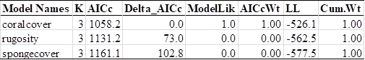

Table 2. AICc table of models with sponge richness as the response variable (target) and the candidate surrogates.

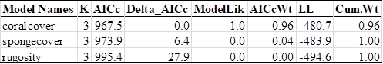

Table 3. AICc table of models with fish richness as the response variable (target) and the candidate surrogates.

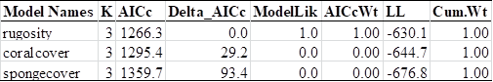

Table 4. AICc table of models with combined richness as the response variable (target) and the candidate surrogates.

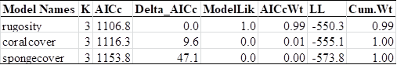

Table 5. AICc table of models with coral richness as the response variable (target) and coral cover as the candidate surrogate.

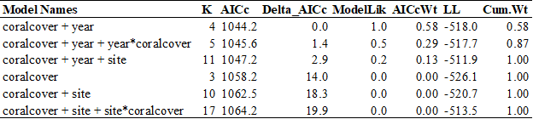

Table 6. AICc table of models with sponge richness as the response variable (target) and coral cover as the candidate surrogate.

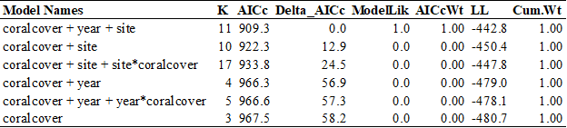

Table 7. AICc table of models with fish richness as the response variable (target) and rugosity as the candidate surrogate.

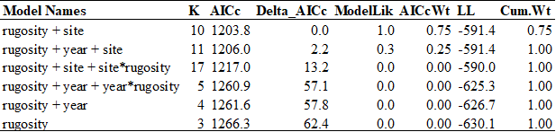

Table 8. AICc table of models with combined richness as the response variable (target) and rugosity as the candidate surrogate.

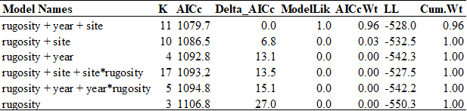

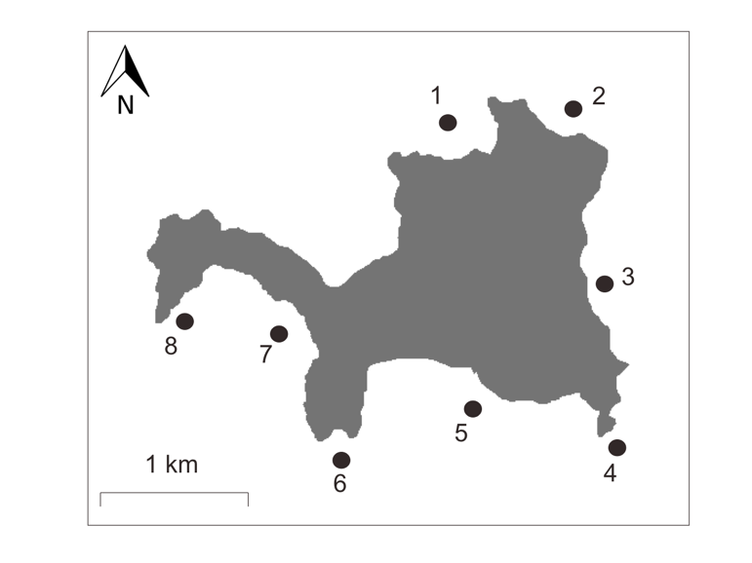

Figure 1. A map of Guana Island, British Virgin Islands, showing the eight study sites: (1) Grand Ghut, (2) Pelican Ghut, (3) Bigelow Beach, (4) Monkey Point, (5) White Bay, (6) Iguana Head, (7) Crab Cove, and (8) Long Point.

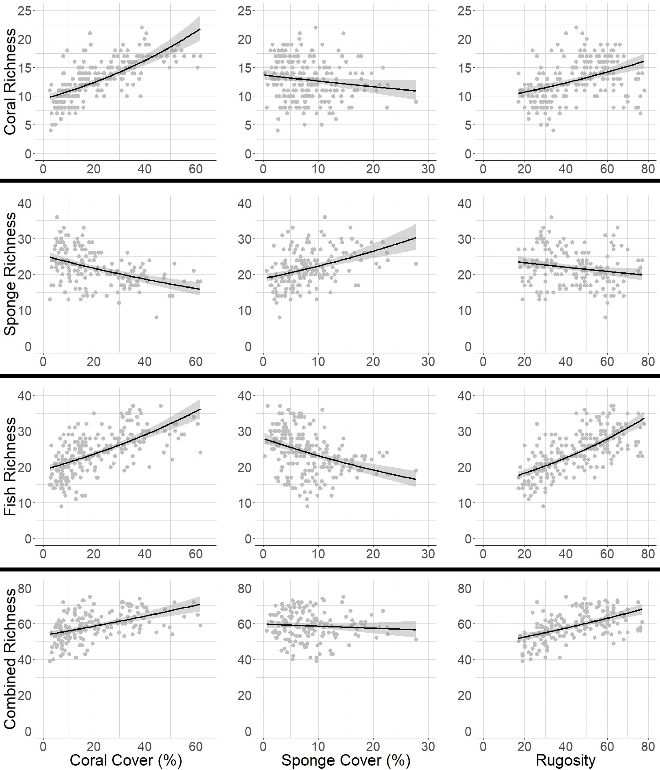

Figure 2. Plots of the targets (rows) and candidate surrogates (columns). 95% confidence intervals shown. Coral cover is the best predictor of coral richness and sponge richness of these candidate surrogates. Rugosity is the best predictor of fish richness and combined richness of these candidate surrogates (Auguie, 2017; Wickham, 2016).

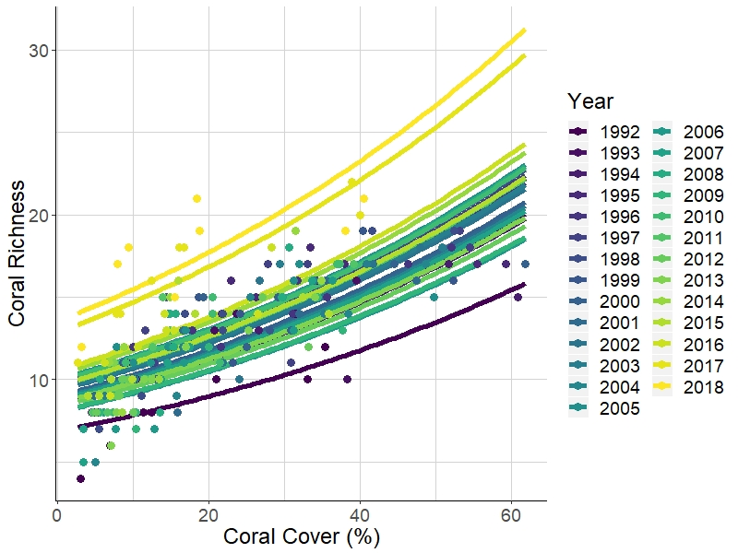

Figure 3. Percent coral cover and coral richness over time (Wickham, 2016).

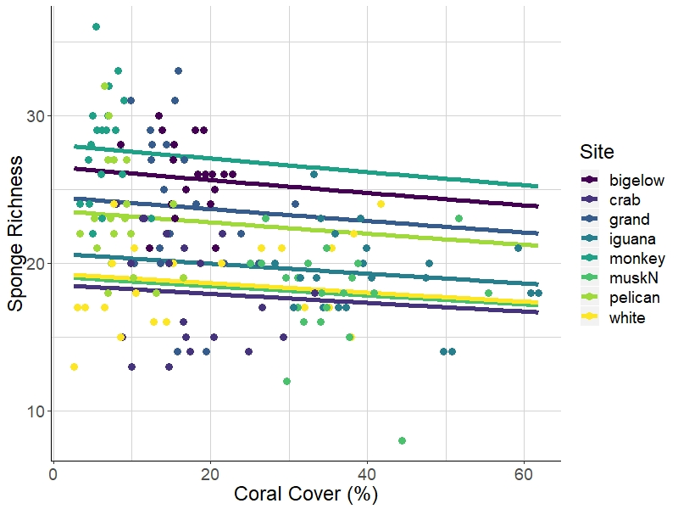

Figure 4. Percent coral cover and sponge richness across sites (Wickham, 2016).

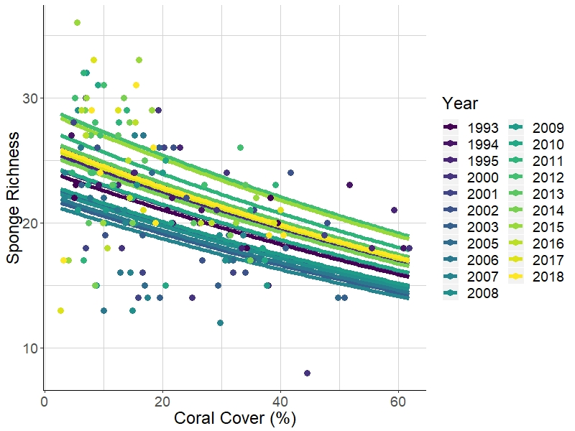

Figure 5. Percent coral cover and sponge richness over time (Wickham, 2016).

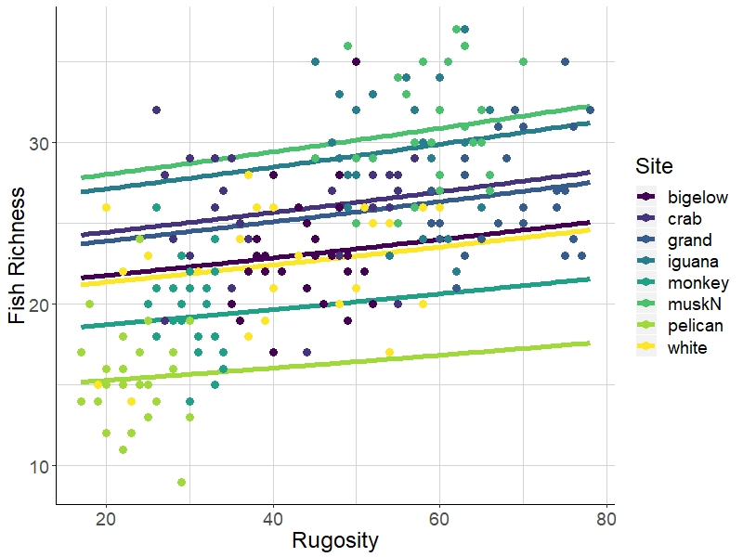

Figure 6. Rugosity and fish richness over time (Wickham, 2016).

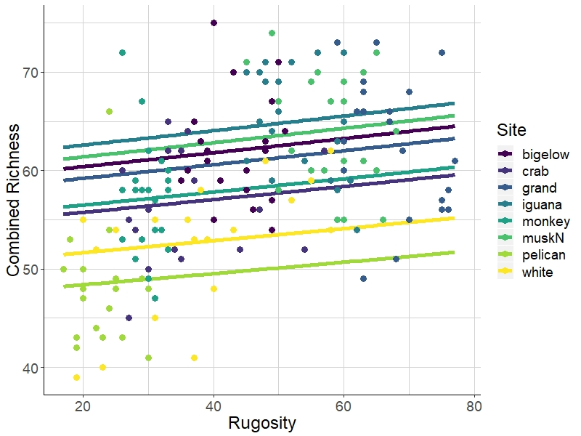

Figure 7. Rugosity and the sum of richnesses across all three major taxonomic groups (coral, fish, and sponge) across sites (Wickham, 2016).

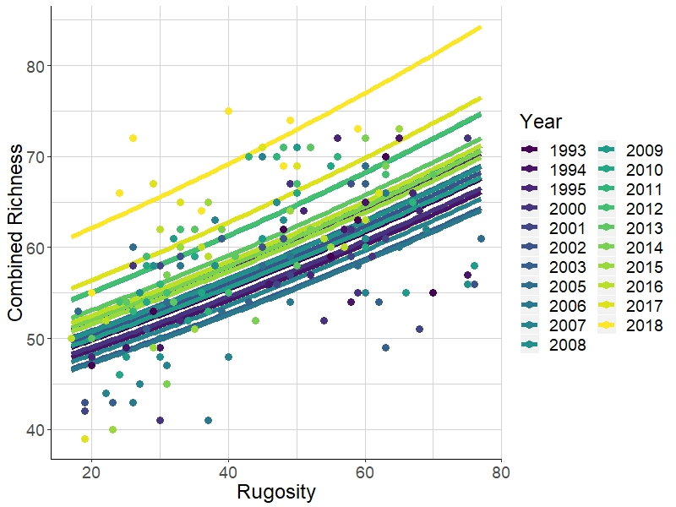

Figure 7. Rugosity and the sum of richnesses across all three major taxonomic groups (coral, fish, and sponge) over time (Wickham, 2016).

Appendix 1: Species included in the surveys.

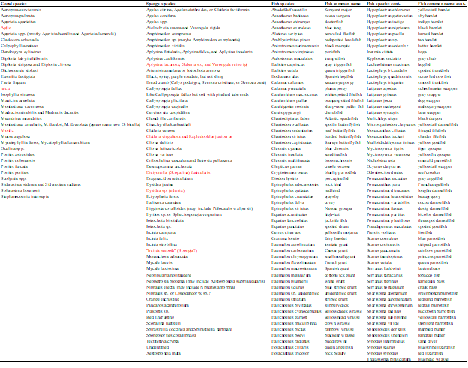

Appendix 2: AICc table of models with coral richness as the response variable (target) where cc = coral cover, sc = sponge cover, r = rugosity, yr = year, x = interaction.

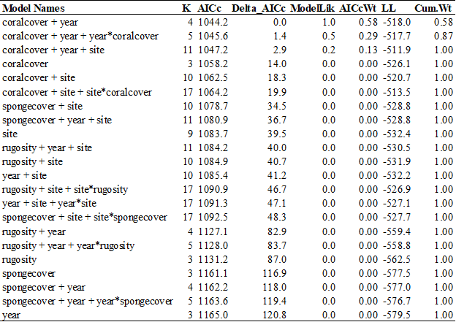

Appendix 3: AICc table of models with sponge richness as the response variable (target) where cc = coral cover, sc = sponge cover, r = rugosity, yr = year, x = interaction.

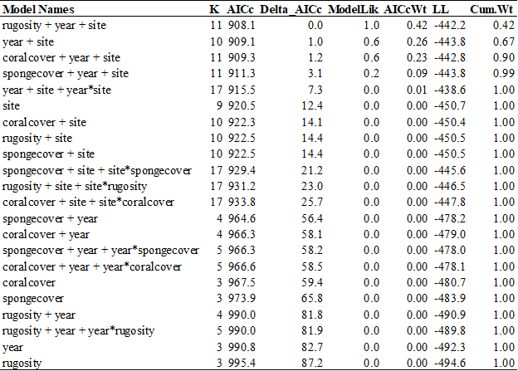

Appendix 4: AICc table of models with fish richness as the response variable (target) where cc = coral cover, sc = sponge cover, r = rugosity, yr = year, x = interaction.

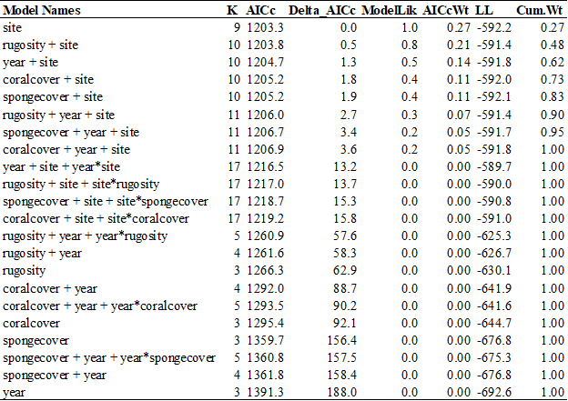

Appendix 5: AICc table of models with combined richness as the response variable (target) where cc = coral cover, sc = sponge cover, r = rugosity, yr = year, x = interaction.

